**Project : Healthcare Telecommunication Systems**

***Phase 3: Data Modeling & Relationships***

1. Standard & Custom Objects

Setup → Object Manager → Create → Custom Object.

Label ---> Patient, Appointment, Prescription.

Plural Label ---> Patients, Appointments, Prescriptions.

Check Allow Reports, Allow Activities, Track Field History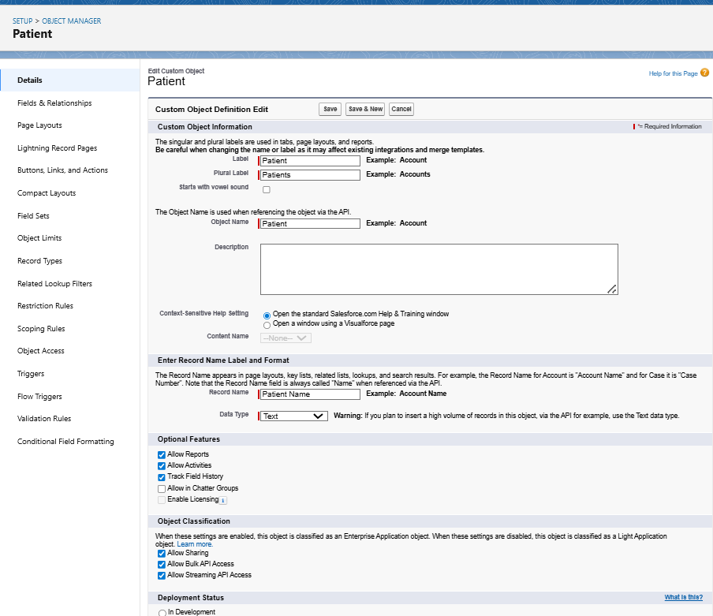

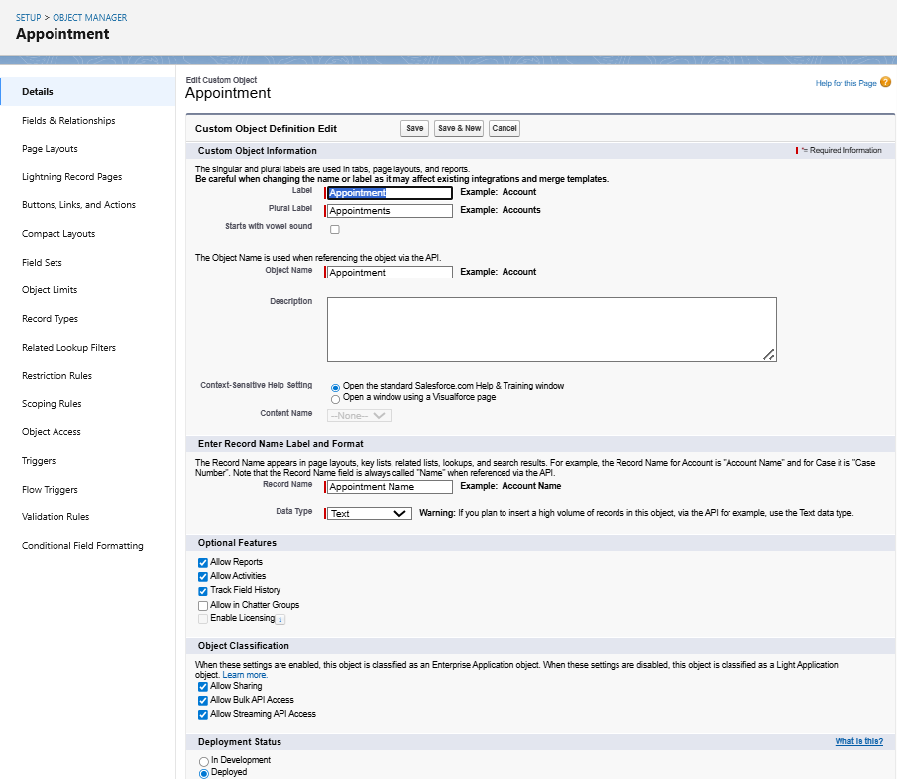

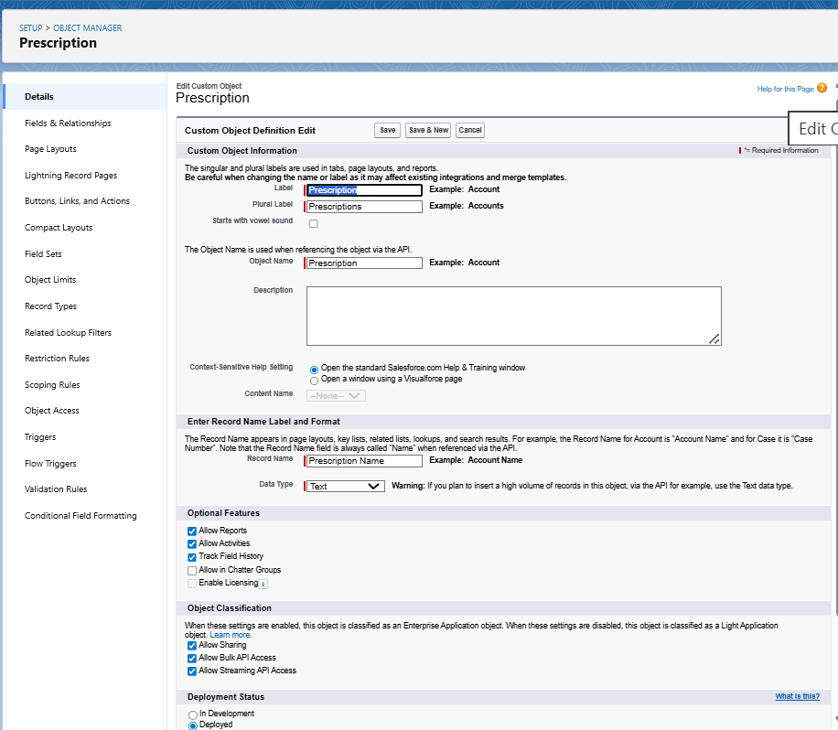

1. Fields
2. Setup → Object Manager → choose object → Fields & Relationships → New.
3. For Patient_c we use field types are Age, Gender, Phone, Email, Medical History.
4. For Appointment_c we use fields are Appointment Date/Time , Patient, Doctor, Status.
5. For Prescription_c we use fields are Patient,Doctor,Medicine,Dosage,NotesMedicine,Dosage,Notes

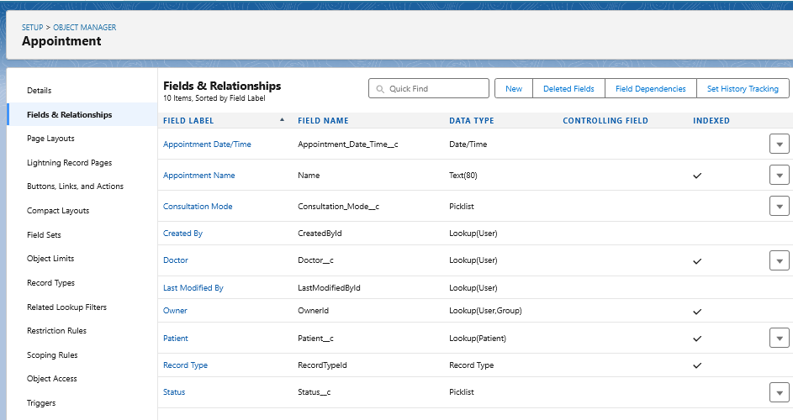

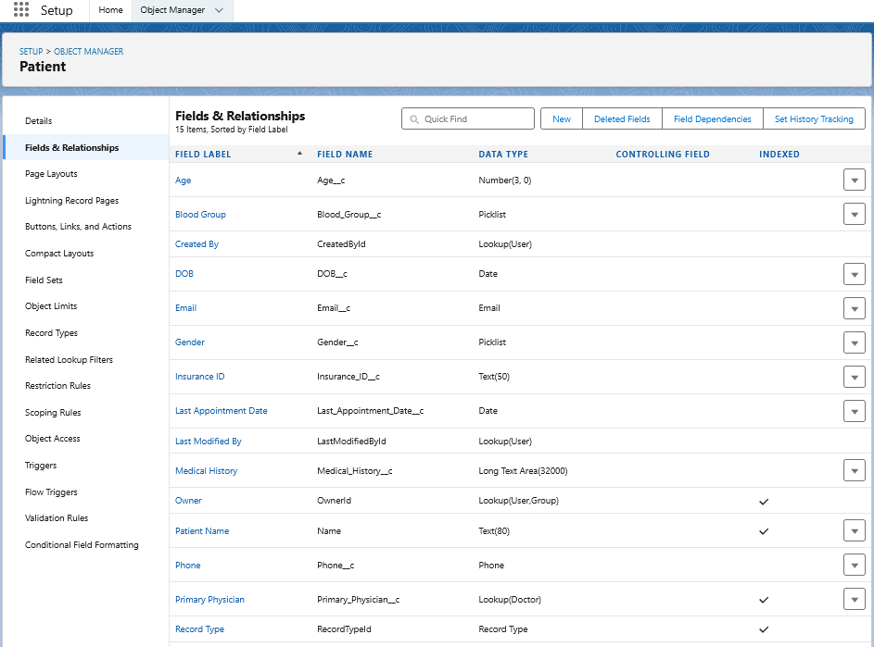

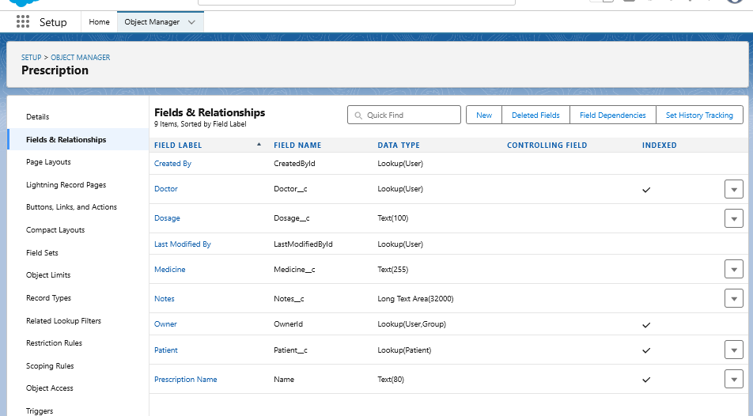

1. Record Types
2. Setup → Object Manager → choose object → Record Types → New.
3. For Appointment create record type as New Consultation, Follow-up , Emergency.
4. For Patient Create record type as Adult, Child, Senior.

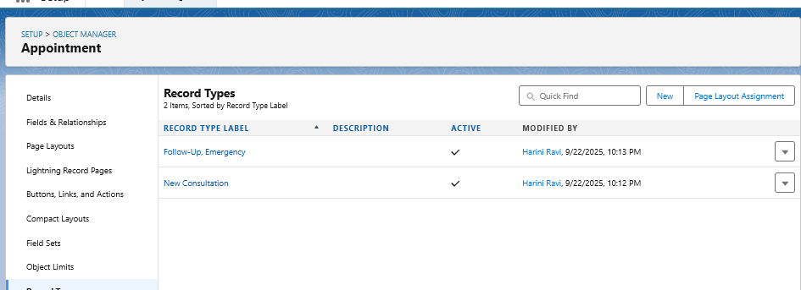

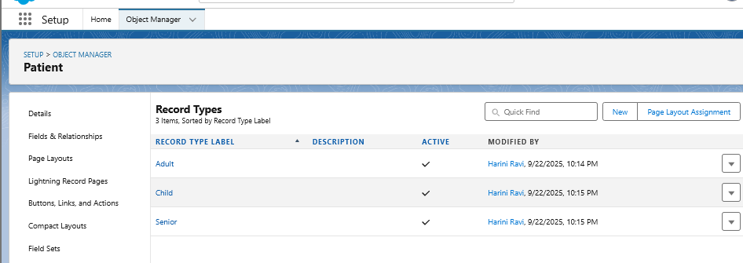

1. Page Layouts
2. Setup ---> Object Manager ---> Select the object ---> page layouts
3. Drag-and-drop fields, sections, related lists, and buttons onto the layout.
4. Doctor Layout → include License Number, Specialty, Availability.
5. Patient Layout → include Insurance Details, Medical History, Last Appointment Date.

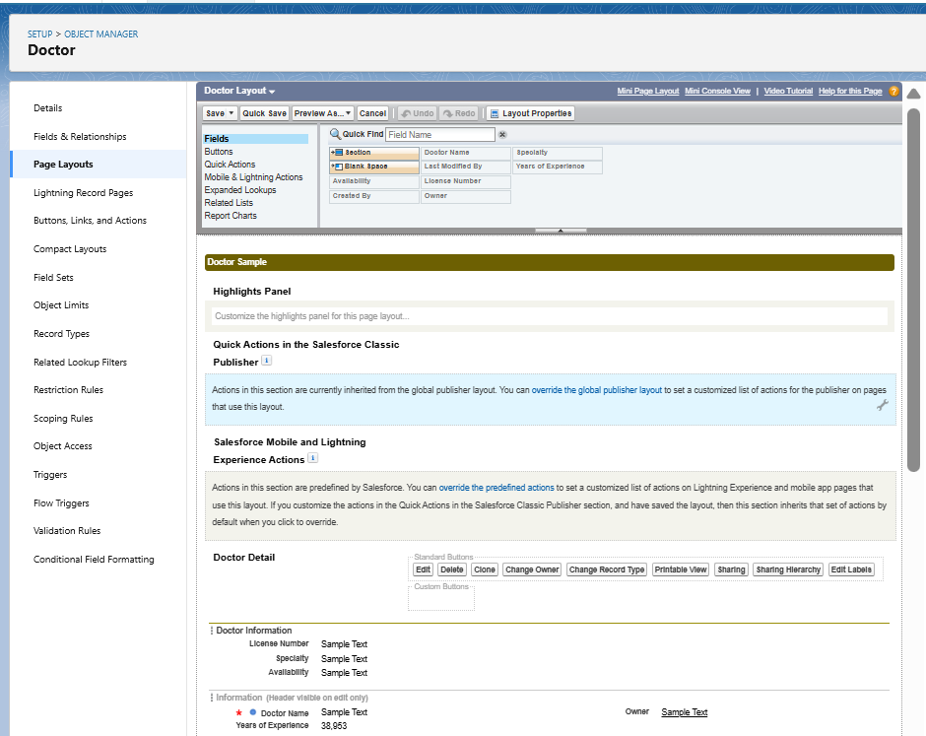

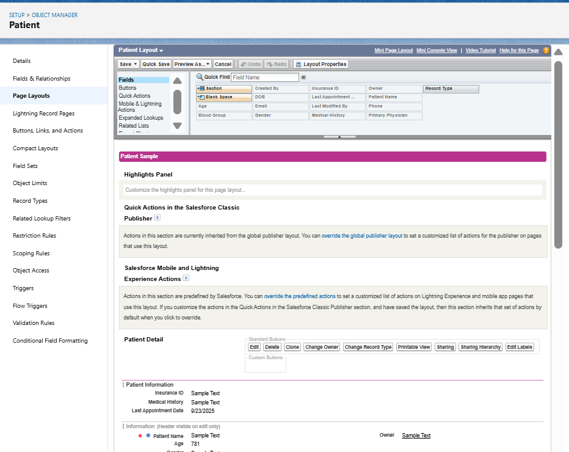

1. Compact Layouts
2. Setup ---> Object Manager ---> Select the object ---> Compact Layouts
3. Create Patient Compact Layout and Add fields.

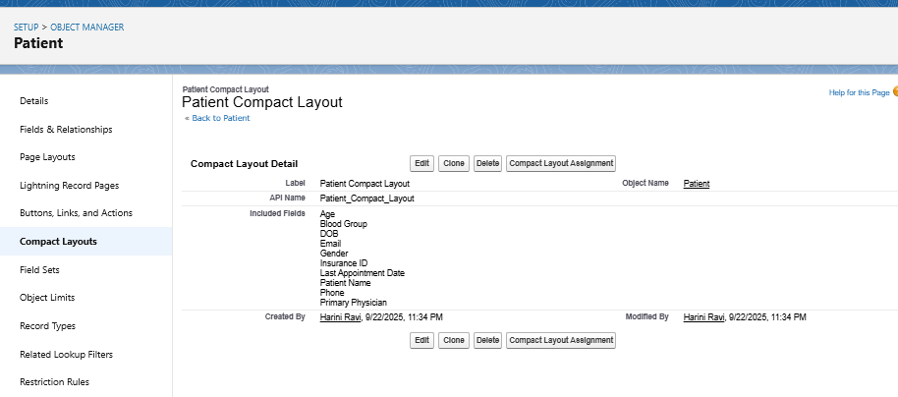

1. Schema Builder
2. Setup ---> Schema builder ---> Check the objects Patient, Doctor, Appointment.
3. Drag field type --> Text, Number, Lookup.

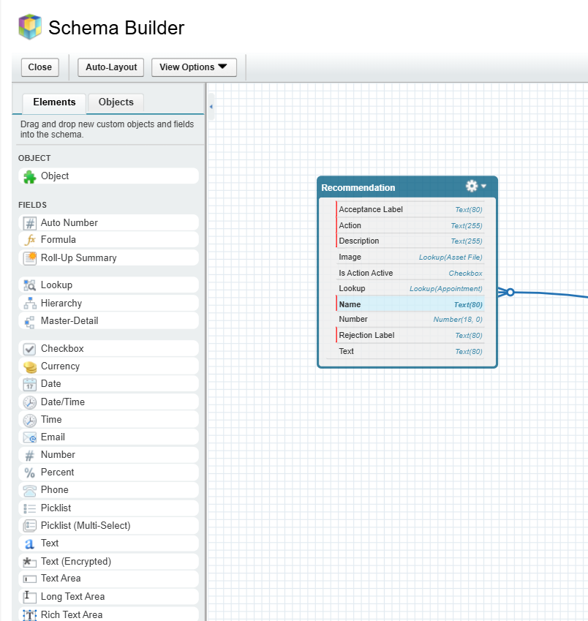

1. Lookup vs Master-Detail vs Hierarchical Relationships
2. Lookup

Setup --> Object Manager --> Choose the Object(Appointment) --> Fields and Relationships --> Lookup Relationship--> Doctor.

1. Master-Detail

Setup --> Object Manager --> Choose the Object(Appointment) --> Fields and Relationships --> Master-Detail Relationship--> Patient.

1. Hierarchical Relationship

Setup --> Object Manager --> User --> Fields and Relationships --> Hierarchical Relationship--> User.

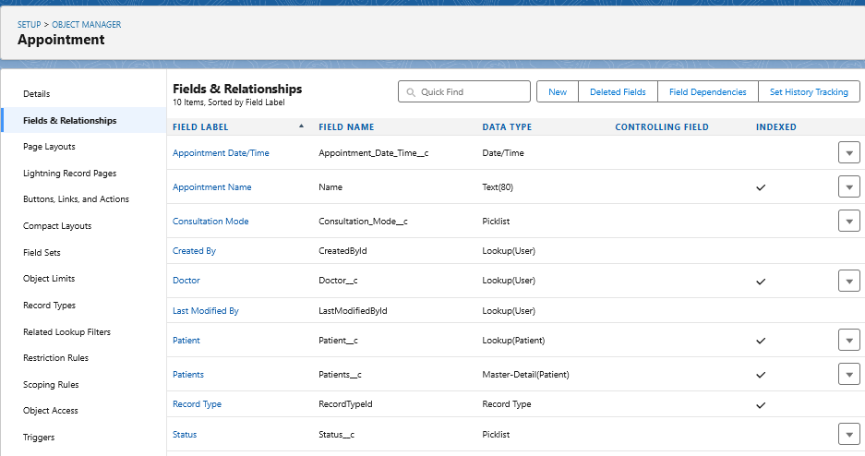

1. Junction Objects

Setup --> object manager --> Create Custom object --> Consultation.

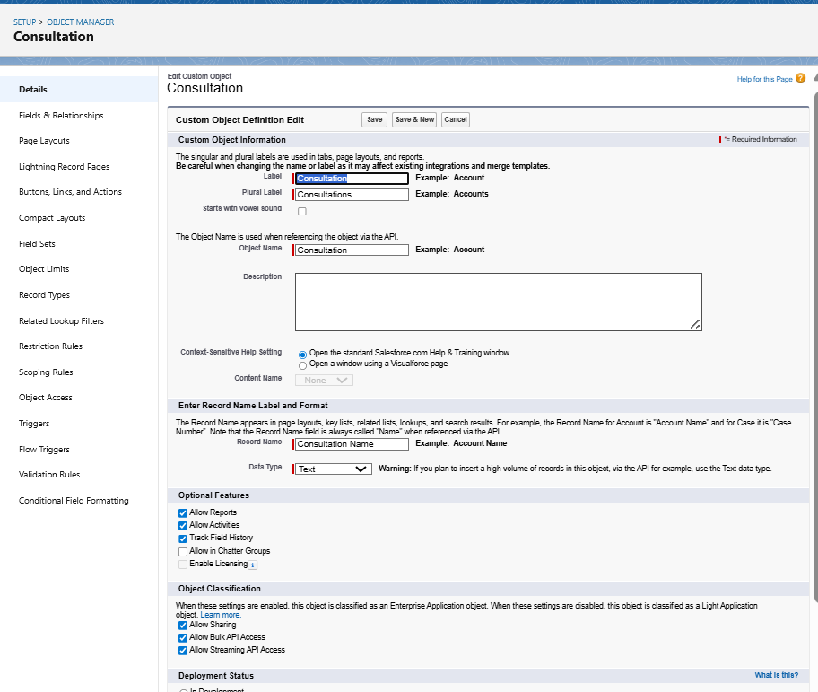

1. External Objects
2. Setup --> External Data Sources --> New External Data Source
3. Name --> Hospital Lab Reports

